**Quiz Application (Android studio) Programming**

Gaurang Sanganee (60%) & Astha Adhikari (40%)

# Overview

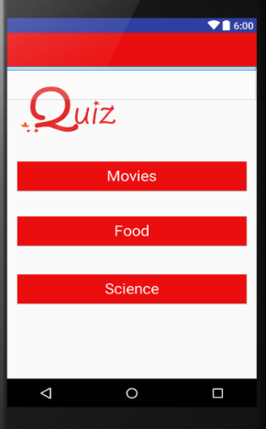To summarise what has been achieved during the course of this project, we can first take a look at the application itself. The application is a simple quiz that has a ‘menu’ activity with 3 different topics to choose from – Science, Food and Movies (more options could easily be added). Following the selection of the quiz, a new activity begins with the quiz itself. The quizzes are currently compromised of 10 questions each (more could easily be added) and the final result is displayed at the end of the application.

Figure 1: Our finished product

The software used to create the application was ‘Android studio’. To learn about the initial concepts involved with creating an application in this software, Lynda.com’s “Android Studio Essential Training” was used.

# Process of making

The process began by choosing a very simple layout and using it to design the first activity which involved 3 buttons with different text and ID’s in order to distinguish between them in our code.

There were many online videos that showed how to get started with the GUI. The one that we found most helpful was a video called “Android App development for Beginners – 11 – Designing the User Interface” on thenewboston.com. *(The process had to be redone when we changed from portrait to landscape which will be talked about further later in the report.)*

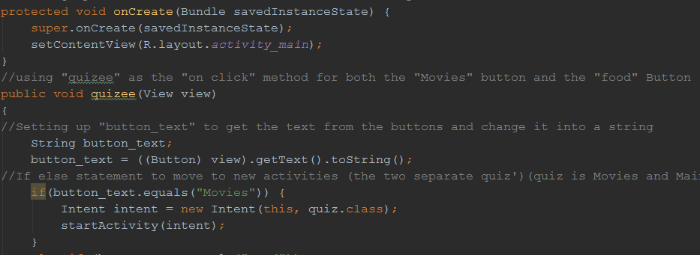Next, we needed to familiarise ourselves with how to incorporate our code into the software in order to create suitable elements such as buttons, radio buttons and text boxes. To do this, the main component was to be able to either “listen” for button clicks or to “view” them. The coding for this was learnt through the use of lectures and the video “Android App Development for Beginners – 27 – Listening for Button Clicks” on thenewboston.com

Figure 2: The code for the first part of our project

Following the creation of the main activity, we needed to create our quiz interface itself and we subsequently needed to find a way to link the two activities. Chapter 4 from the book extract of “Android How to Program with an Introduction to Java” was particularly helpful with this and subsequently resulted in code that allowed for the quiz to progress after clicking on the button from the initial activity. In this stage, we also managed to create separate activities for each of our quizzes based on a common quiz layout. We then needed to link this to a results page to present the user with their result out of 10.

To complete the final aspect – the results page, we needed to find a method to collect the data we obtained from the users answers and then move them to a final activity that could present this data as a string. Previous java exercises were particularly helpful in presenting the data as a string. However to learn how to collect the data we had to, once again, refer to chapter 4 from “Android How to Program with an Introduction to Java.”

# Challenges

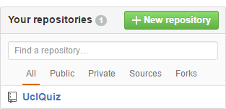Although this concludes the main aspects of the application itself, there were a few other challenges that we had to overcome throughout the process. The first of these was to create a Git repository in order to push and pull the code from both of our individual sections. To do this, we used the website called GitHub and created a repository under the name “UCLQuiz.” Learning how to do this and then using GitHub to its fullest extent required using the source provided called “Chapter 6:  Using Software Version Control with Git”.

Figure 3: Our Git repository

Another challenge was being able to check whether our code was working or not throughout the process. This was initially done by simply running the application on an emulator provided on Android Studio itself. However, this occasionally led to the application crashing for unknown reasons. Due to this and the fact that the emulator took quite a long time to load up, we decided to start checking whether our application worked on our android phones which was a lot more time efficient.

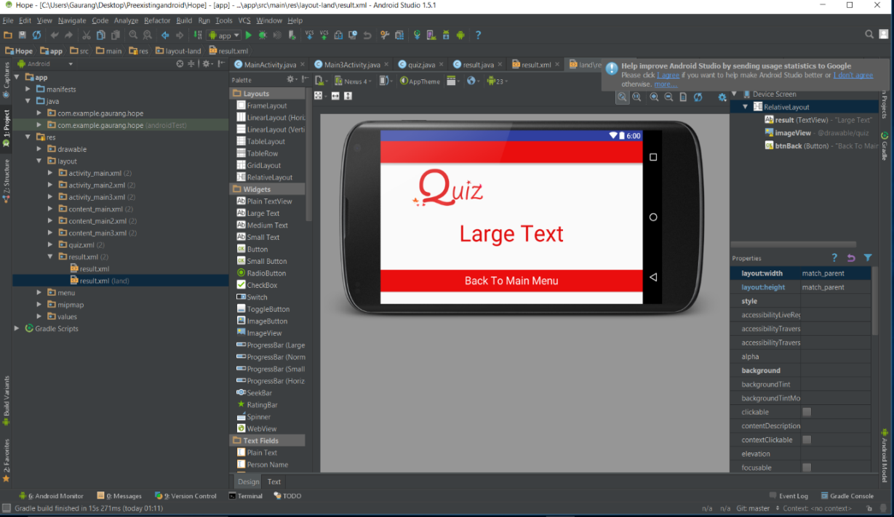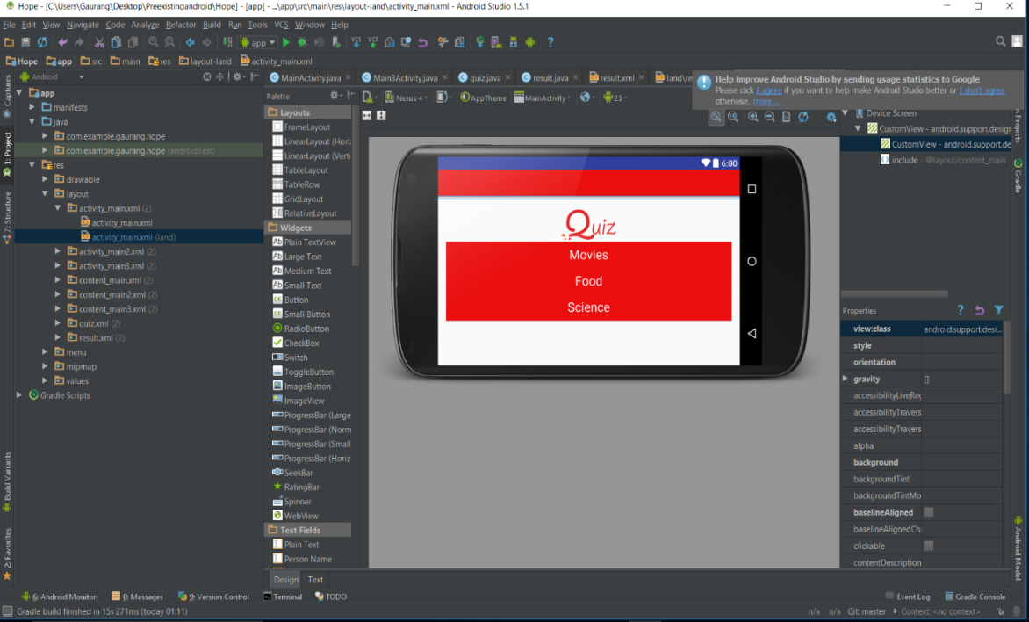The final challenge was creating a landscape version of the quiz itself. Initially this seemed like it would prove a difficult challenge. However, the use of android studios allowed for a quick solution to this problem which was to create “-land” activities for each respective activity. This still required for the GUI to be modified slightly in order to make the activities presentable to a user but it did not take too long to rearrange the buttons and text. Nevertheless, there still posed the problem that during the quiz activity, if the user was to change from landscape to portrait or vice-versa, the quiz would restart.

Figure 4: The landscape view of our product

Finally, it is worth mentioning that the application works with its intended purpose on android devices in both landscape and portrait modes. Furthermore, the source code is quite simply presented and it would be easy enough to change the questions and answers within the code. In time, there is also the possibility of adding further features such as a timer, presenting the incorrect answers at the end, sharing the result on social media or even simply adding more quiz options.

## Our Git Repository: <https://github.com/gsanganee/UclQuiz>